Basic Surveying – TREC #6893

Instructor – Timothy J Howell TREC #1556

Course Outline

Definition and History
A brief primer on the origins of surveying

Measurements
Distances and angles and how to interpret what they mean

Closure
Understanding what that really means

Evidence
Hierarchy of evidence

Curves
Types of curves and how to read curve data

Descriptions
Reading and understanding what is in a legal description

Easements and Rights of Way
The differences between and easement and a right of way

Process
The process of surveying from order to completion

Plats
What needs to be on a plat

Retracing
How to follow a survey on the ground

Common Errors
Mistakes made by surveyors.

Prescriptive Rights and Adverse Possession
Legalized Land Theft

Rules
Regulations governing land surveying

Elevation Certificates
Flood plains, special flood hazard areas, and completing the FEMA elevation certificate

Biblical Survey References
Proverbs 22:28 Remove not the ancient landmark, which thy fathers have set.
Deuteronomy 19:14 Thou shalt not remove thy neighbors’ landmark which they of old time have set, in thine inheritance which thou shalt inherit, in the land that Jehovah thy God giveth thee to possess it.
Deuteronomy 27:17 cursed be he that removeth his neighbor's landmark. And all the people shall say, amen.
Job 24:2 Some remove the landmarks; they seize and devour flocks.
Zechariah 2:1-2 I lifted up mine eyes again, and looked, and behold a man with a measuring line in his hand. Then said I, Whither goest thou? And he said unto me, to measure Jerusalem, to see what is the breadth thereof, and what is the length thereof.
Ezekiel 42:16-19 He measured on the east side with the measuring reed five hundred reeds, with the measuring reed round about. He measured on the north side five hundred reeds with the measuring reed round about.
He measured on the south side five hundred reeds with the measuring reed. He turned about to the west side, and measured five hundred reeds with the measuring reed.

Conversions
To | US Survey Feet
1 Mile | 5280 feet
1 Chain | 66 feet (100 links)
1 link | 0.66 feet
1 Rod (pole) | 16.5 feet
1 yard | 3 feet
1 meter | 3.28083333 feet
1 inch | .083333 feet
9 ft² in a square yard
27 ft³ in a cubic yard
43560 ft² in an acre
640 Acres in a Square Mile
1 Square Mile in a Section
36 Sections in a Township
Definitions:
Approved Area: “Modern” septic systems have a primary and reserve approved area for septic field lines. The size of the area needed for subsurface disposal is determined by the soil absorption rate. The State requires that, in case of catastrophic failure of the primary installation, there must be an alternative (reserve) site maintained. The reserve area must be maintained as such and cannot be disturbed.
Bearing: Angular measurement express in Degrees, Minutes, Seconds (DMS) with cardinal directions attached (N27°15’34”W). Bearings are based on quadrants where North and South are represented with 0 degrees and East and West are 90 degrees. A bearing cannot exceed 90 degrees and is expressed as a function of North or South. N27°15’34”W is read as “North twenty seven degrees fifteen minutes thirty four seconds west.”
Building setback: A specific distance set by the local municipality or developer to determine the closest a building can be built to some feature. This is usually measured from the property line but can be from any definable feature.
Building Width: The minimum width the lot can be at the building location. In the case of a “pie shaped” lot where the sidelines converge at the front, the minimum building width may be significantly further back than the building setback line.
Closure: The mathematical calculation of the difference between the starting point and the ending point.
Tennessee State Minimum Standards
Urban Survey – Category “I” = 1:10,000
Rural Survey – Category “II” = 1:7,500
All Others – Category “III” = 1:5,000

Condominium: The ownership of single units in a multiple unit structure or structures with common elements” TCA 66-27-102 (2)
Curve, (horizontal, circular)
Radius: The distance from the center point of the curve and perpendicular to any point on it.
Delta: Expressed typically in DMS format and the internal angle between the radius lines at the beginning and end of the curve.
Arc: The length of the curve following along its’ concave/convex shape.
Tangent: The imagined line extended from the tangent entering the curve to the point where the exiting tangent intersects. This is expressed as a length.
Chord: Usually expressed with a bearing and distance is the imagined straight line between the start and end of the curve.
Right or Left: These refer to the direction the
Dedicated ROW: When dividing property, most municipalities require that roads be dedicated “fee simple” as roads. This also applies to existing roads. Most roads have a specific width requirement. If the property, before division, encroached into this width, then the amount required to meet “our” half of the width must be dedicated to the local municipality. (If I owned to the centerline of a road and decided to divide my property, I would have to “give up” my half of the road, typically 25 feet). This dedication can affect a property’s ability to be divided. The balance of the property AFTER dedication must still meet minimum lot density.
Density: A ratio comparing housing unit/lot to property size. (IE: a minimum lot size of 7,500 ft² would have a maximum density of 5.8 lots per acre)
Flag lot: A lot with a “flag” shape where a narrow strip of land connects the main parcel with its required road frontage.
In-house: A term given to subdivision approvals that are done “administratively” without having to be presented to the planning commission.
Minimum lot size: The smallest a lot may be in a particular area with certain features (ie: slope, public water/sewer, etc.)
Monument: Any number of items used to mark property corners.
Percolation Test: A method used to determine the absorption rate of water into specific soil types. Percolation tests are typically used where the soil is of a type that the rate of absorption is questionably high and therefore must be established for that site specifically.
Point of Beginning (POB): An arbitrary point assigned to metes and bounds descriptions as a starting point. Typically, a POB is locatable by some external reference (distance from an intersection, etc).
Private Road: A road or through fare owned and maintained by individual land owners either independently or through an association. Although privately owned and maintained, private roads must be built to the same standards (in most regions) as their public counterpart.
Public Road: A road or though fare maintained by municipality for the use of the public (the municipality may or may not own said road or even have an easement).
PUD: A Planned Unit Development (PUD) is a method of developing land with control in place for construction. A PUD typically must follow the same basic guidelines of subdivision regulations with setbacks being the largest exception.
Public Utilities: Water, sewer, power, etc. supplied by an approved utility district.
Road frontage: The distance along a public or private road.
Sight Distance: Determined by the local municipality, there can be a minimum distance a driver can see or be seen that can govern road layout as well as drive connections and intersections.
Slope: The mathematical calculation of vertical change divided by horizontal distance. It is typically expressed as a percent. Both lots and roads can be affected by slope. When constructing a new road (and sometimes a drive) there is a maximum slope that may be achieved. The specific slope is determined by the local municipality. Lots may also be governed by slopes. Some regions, especially those in more mountainous areas, have a sliding scale for lot size based on the average slope. Both the method of slope determination and the percent of slope are established by the local municipality.
Septic System: Also known as a subsurface disposal system. A means of disposing of sewage from a house or other structure. The system is comprises of multiple elements, the minimum of which is a septic tank and field lines. The tank is used to collect and separate solids from the waste water. The waste water “effluent” is piped to the field lines for absorption and evapotranspiration. Field lines consist of pipes (or chambers) installed under the surface (usually about 48” to the bottom of the lines). The liquid is absorbed down, into the ground as well as up through the plant roots and out into the air.
Soil Map: A high-density soil must be prepared by a State licensed Soil Scientist. These soil maps are used to determine the viability of subsurface sewage disposal (septic system).
Subdivision: Any subsequent division of land or alteration of boundaries.
TCA 13-4-301 (4)
(A) "Subdivision" means, in any county having a population of not less than thirty-two thousand seven hundred (32,700) nor more than thirty-two thousand seven hundred sixty (32,760), according to the 1980 federal census or any subsequent federal census, the division of a tract or parcel of land into two (2) or more lots, sites or other division of less than five (5) acres for the purpose, whether immediate or future, of sale or building development, and includes resubdivision and, when appropriate to the context, relates to the process of subdividing or to the land or area subdivided;
(B) (i) "Subdivision" means, in all counties except those in subdivision (4)(A), the division of a tract or parcel of land into two (2) or more lots, sites, or other divisions requiring new street or utility construction, or any division of less than five (5) acres, for the purpose, whether immediate or future, of sale or building development, and includes resubdivision and when appropriate to the context, relates to the process of resubdividing or to the land or area subdivided.
(ii) As used in subdivision (4)(B)(i), "utility construction" does not include the mere extension of individual service pipes or lines for the purpose of directly connecting a single lot, site or other division to existing utility mains.
Tangent: “…meeting a curve or surface in a single point if a sufficiently small interval is considered” (Merriam-Webster).
Traverse: “9 : a line surveyed across a plot of ground” (Merriam-Webster). Traversing in surveying means to move the instrument while maintaining orientation to the rest of the project
Traverse Point: The position the survey equipment occupied, usually marked with a nail or some similar monument. A traverse point is not necessarily relevant to the boundary beyond its use by the survey crew.

Links
Title Searcher – www.titlesearcher.com
Tax Assessment Data – www.assessment.state.tn.us
Tennessee Property Viewer – tnmap.tn.gov/assessment/
Knox GIS – www.kgis.org
Knox County Assessors Data – tn-knox-assessor.publicaccessnow.com/PropertyLookup.aspx
FEMA Map Servicing Center –msc.fema.gov/webapp/wcs/stores/servlet/FemaWelcomeView?storeId=10001&catalogId=10001&langId=-1
Blount County Plats – www.blounttn.org/weblink7/browse.aspx?dbid=0&startid=40474
Site with links above – www.tnlds.com/tstart/

Elements of a Curve
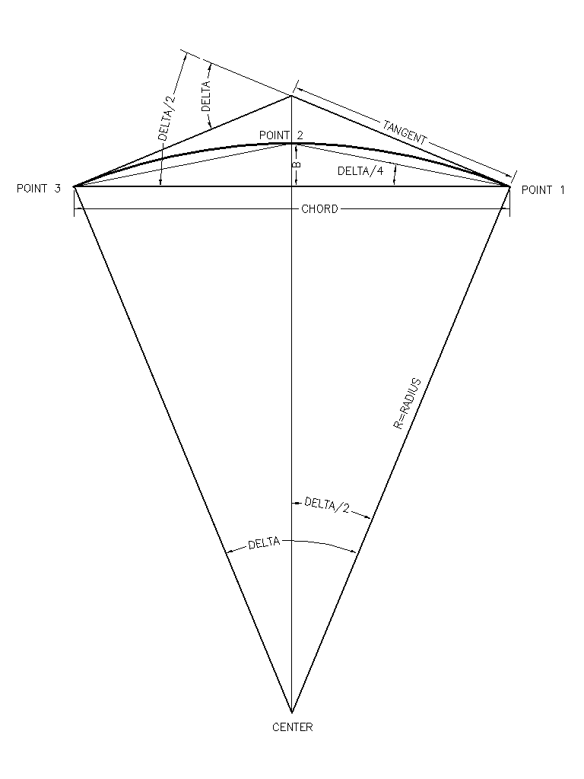
- Radius
- Length (arc length)
- Tangent
- Delta (Δ)
- Chord Distance
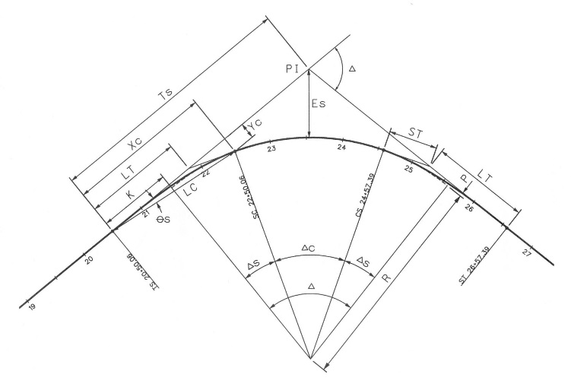
- Chord Bearing

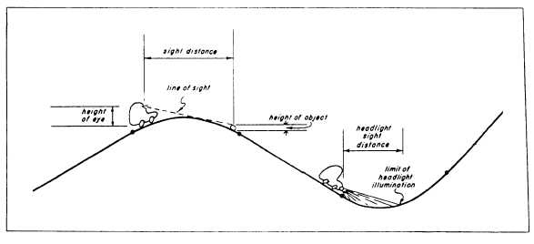
Vertical Curves
Spiral and Circular Curves

